Movo Aviation
Drone imagery tests
27 March 2016
Glencoe, IL
DJI Phantom 4
Analysis: As the following table shows, still images at a 45-degree offset produce adequate details at distances of 10, 15, and 20 feet.
Horizontal distance | Height | Image | Comment
10 feet | 10 feet | 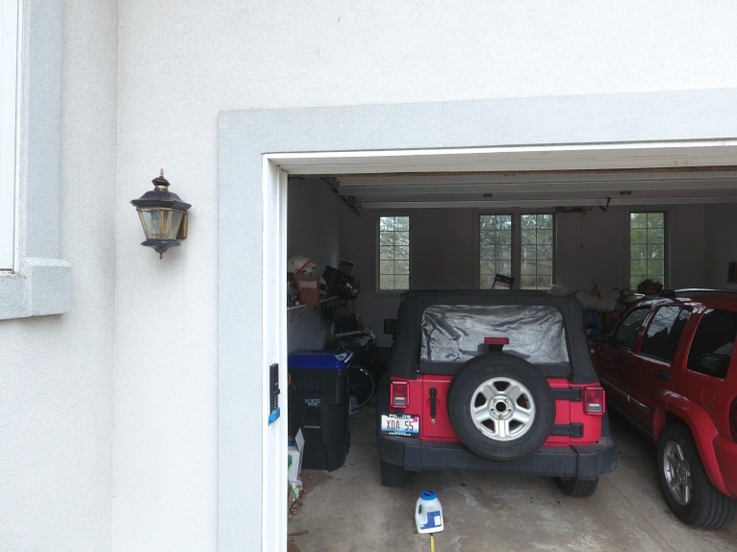
15 feet | 15 feet | 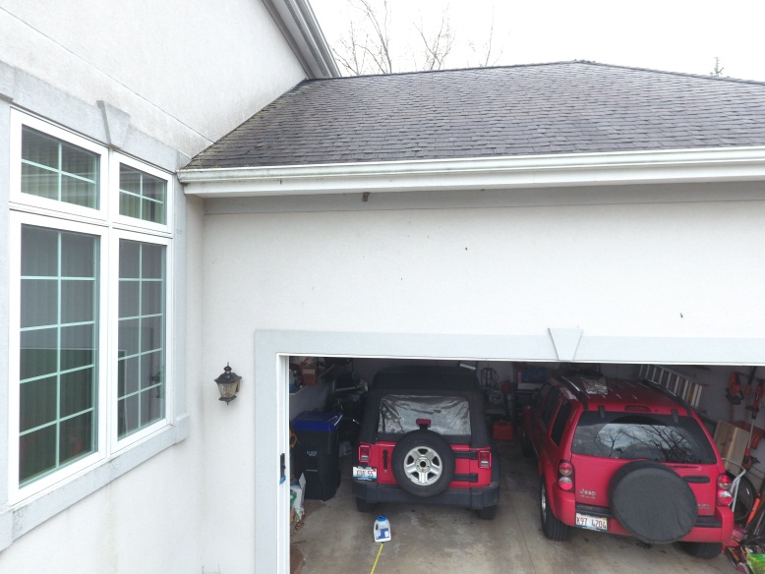
20 feet | 20 feet | 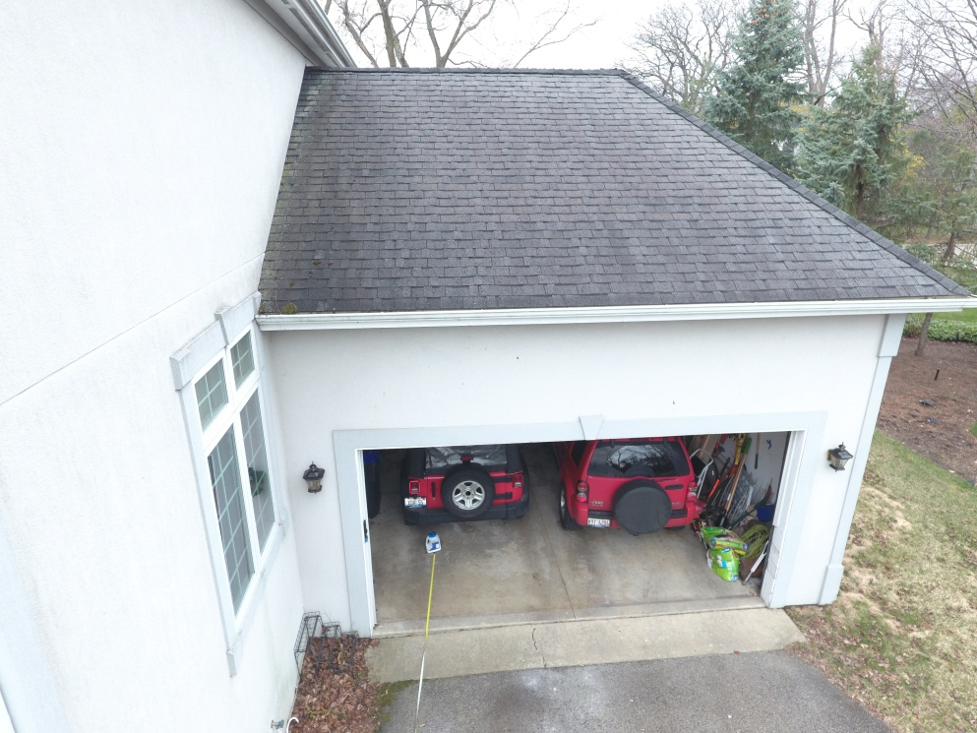 | Resolution is sufficient to make plate clearly readable when photo is zoomed in editor

